This patient is for

* Lumbar/Thoracic/Cervical /Pelvis/Lumbo- Sacral plexus/Brachial Plexus
* Open/Closed
* With Sedation / Without Sedation
* With/ Without contrast
* Special technique for Artefact reduction from previous Hardware

General MRI guidelines:

* MRI should be of at least 1.5 Tesla or above.
* For Patients with hardware will prefer 1.5 Tesla
* Please use optimal TR/ TE, Field of View, Matrix, voxel size and slice thickness

for good resolution.

* Please take care to orient the cuts for axial, sagittal and coronal cuts.
* Make sure that Field of view covers the entire spinal element and beyond as described below
* We prefer closed MRI – if not possible – patient can be send to- wide bore Machine before going for – Open MRI.

Please provide us with following MRI sequences:

Cervical Spine

* Sag T2—FSE/TSE (Required)
  + The Field of View should be from Pons to T4 and from one CM Right to the transverse process to the one CM beyond the left transverse process of T1
  + The cuts should be parallel to a plane joining the center of the body and the center of the spinous process.
  + Position the block parallel to the spinal cord
  + Saturation band in the neck in front of esophagus.
* Sag T1—FSE/TSE (Required)
  + The Field of View should be from Pons to T4 and from one CM Right to the transverse process to the one CM beyond the left transverse process of T1
  + The cuts should be parallel to a plane joining the center of the body and the center of the spinous process.
  + Position the block parallel to the spinal cord
  + Saturation band in the neck in front of esophagus
* SAG STIR T2 (Required)
  + The Field of View should be from Pons to T4 and from one CM Right to the transverse process to the one CM beyond the left transverse process of T1
  + The cuts should be parallel to a plane joining the center of the body and the center of the spinous process.
  + Position the block parallel to the spinal cord
  + Saturation band in the neck in front of esophagus
* Axial T2 FSE/TSE (Medic) (Required)
  + While taking the axial cuts please align the cuts to the disc
  + Please take at least 3 cuts through the disc area and 1 cut through the endplate – total 5 per block
  + Use at least 5 blocks
  + Do not put saturation band.
* Axial T1TSE (Required)
  + While taking the axial cuts please align the blocks to the disc both in sagittal and coronal plane
  + Please take at least 3 cuts through the disc area and 1 cut through the endplate – total 5 per block
  + Use at least 5 blocks
  + Do not put saturation band.
* Axial -Gradient Spin Echo images (Optional) (Required)
  + While taking the axial cuts please align the blocks to the disc both in sagittal and coronal plane
  + Please take at least 3 cuts through the disc area and 1 cut through the endplate – total 5 per block
  + Use at least 5 blocks
  + Do not put saturation band.
* 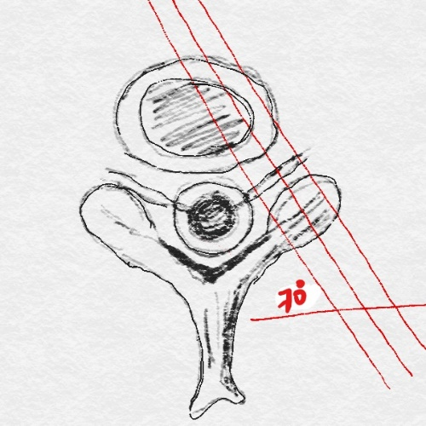Right Foraminal views (Optional) (Required)
  + 20 to 30 degrees oblique to coronal Sag T1
  + 3mm slices perpendicular to the neural foramen, set up on the axial T1 image at the level of C5/6 or C6/7.
* Left foraminal views (Optional) (Required)
  + 20 to 30 degrees oblique to coronal Sag T1
  + Sections to be acquired in the plane of the emerging nerve roots
* Coronal T2 image (Optional) (Required)
  + Field of view 1cm front of the vertebrae to 1 cm beyond the spinous process.
* Myelogram (Required)
  + 3-dimensional Myelogram.
  + Heavy T2 weighted with- MIP – FSE – Fat suppression

Lumbar Spine

* Sag T2 FSE/TSE (Optional) (Required)
  + The Field of View should be from T11 to coccyx and from one end of the Right transverse process to the other end of left transverse process.
  + The cuts should be parallel to a plane joining the center of the body and the center of the spinous process.
  + Position the block parallel to the spinal cord
  + Saturation band on the abdomen in front of Aorta and blood vessels.
* Sag T1 FSE/TSE (Optional) (Required)
  + The Field of View should be from T11 to coccyx and from one end of the Right transverse process to the other end of left transverse process.
  + The cuts should be parallel to a plane joining the center of the body and the center of the spinous process.
  + Position the block parallel to the spinal cord
  + Saturation band on the abdomen in front of Aorta and blood vessels.
* SAG STIR T2 (Optional) (Required)
  + The Field of View should be from T11 to coccyx and from one end of the Right transverse process to the other end of left transverse process.
  + The cuts should be parallel to a plane joining the center of the body and the center of the spinous process.
  + Position the block parallel to the spinal cord
  + Saturation band on the abdomen in front of Aorta and blood vessels.
* AX T2 FSE/TSE (Optional) (Required)
  + While taking the axial cuts please align the blocks to the disc both in sagittal and coronal plane
  + Please take at least 3 cuts through the disc area and 1 cut through the endplate – total 5 per block
  + Use at least 5 blocks
  + Do not put saturation band.
* Ax T1 FSE /TSE(Optional) (Required)
  + While taking the axial cuts please align the blocks to the disc both in sagittal and coronal plane
  + Please take at least 3 cuts through the disc area and 1 cut through the endplate – total 5 per block
  + Use at least 4 blocks
  + Do not put saturation band.



* Right Foraminal views (Optional) (Required)



* + 20 to 30 degrees oblique to coronal Sag T1
  + 3mm slices perpendicular to the neural foramen, set up on the axial T1 image at the level of L3/L4 or L4/L5.
* Left foraminal views (Optional) (Required)
  + 20 to 30 degrees oblique to coronal Sag T1
  + 3mm slices perpendicular to the neural foramen, set up on the axial T1 image at the level of L3/L4 or L4/L5.
* Coronal T2 image (Optional) (Required)
  + Field of view 1cm front of the vertebrae to 1 cm beyond the spinous process.
* Myelogram (Required)
  + 3-dimensional Myelogram.
  + Heavy T2 weighted with- MIP – FSE – Fat suppression
* NEUROGRAPHY (Optional)

## Contrast MRI

* Sagittal T1 TSE Fat saturated sequence with IV contrast.
* Axial T1 TSE Fat Saturated sequence with IV contrast.

## MRI on patients with metallic implants from previous spine surgery

* If Implants are there in the spine, please use appropriate sequences- appropriate sequences will not blur the image quality at implant site.
* Switch to TSE T2 for all levels of metal hardware with gradient echo sequence to minimize the influence of CSF pulsation.
* MR artifacts can be minimized by using newer techniques e.g. SEMAC-VAT and VAT techniques