Genicular Nerve Block & Radiofrequency Ablation of Knee Joint

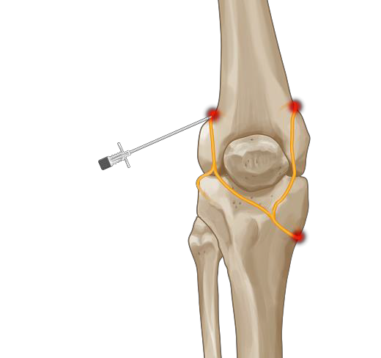Chronic osteoarthritis pain of the knee is often not effectively managed with prescribed medications. Radiofrequency (RF) ablation, when applied to articular nerve branches (genicular nerves), provides a therapeutic alternative for effective management of chronic pain associated with osteoarthritis of the knee.

Although surgery is generally effective for patients with advanced disease, some older individuals with other chronic conditions may not be appropriate surgical candidates. In addition some patients do not wish to consider surgery and prefer non- surgical options. In these patients, radiofrequency ablation of the genicular nerves might be a successful alternative to surgery. This procedure is based on the theory that cutting the nerve supply

to a painful structure may alleviate pain and restore function.

# Genicular Nerve Block

Patients with chronic knee pain that has failed to respond to conservative care may be candidates for a genicular nerve block. This procedure is based on a theory that blocking the nerve supply to a painful area may alleviate pain and restore function. The knee joint is innervated by the articular branches of various nerves, including the femoral, common peroneal, saphenous, tibial, and obturator nerves.

These branches around the knee joint are known as genicular nerves. Several genicular nerves can be easily approached with a needle under fluoroscopic guidance. Patients can get a diagnostic genicular nerve block to determine if this will provide adequate relief.

A Genicular nerve block is a procedure where these nerves are anesthetized (“blocked”) with local anesthetic injected through small needles. The procedure is performed with live x-ray guidance (fluoroscopy) to ensure proper needle placement. It generally takes 5 to 10 minutes for the procedure.

# Indications for genicular nerve blocks

* Patients with chronic knee pain secondary to osteoarthritis
* Patients with failed knee replacement
* Patients unfit for knee replacement
* Patients who want to avoid surgery

# Diagnostic genicular nerve blocks

These injections are performed under fluoroscopy guidance. A small amount of local anaesthetic (1- 2ml) of lidocaine or bupivacaine is injected around the superior lateral (SL), superior medial (SM) and the inferior medial (IM) branches. A response is considered positive if there is at least 50% reduction in pain in the 24hrs following injection.

# Radiofrequency Ablation of genicular nerves

Patients with a positive response are offered radiofrequency ablation for a more sustained response. The procedure is usually done on an outpatient basis under fluoroscopic guidance to ensure accuracy of needle placement. Patients need to be aware that the outcome of the procedure is variable and they may not receive the desired benefits. Similarly, they must be aware of the transient nature of the therapeutic benefits and that there may need repeated injections.

Radiofrequency treatment is the second of a two-step procedure. The first step is diagnostic (the Genicular nerve block) as described above. Patients who experience good pain relief following diagnostic injections are offered radiofrequency denervation treatment. This involves creating a heat lesion around the genicular nerves carrying painful impulses from the knee joint. Successful treatment can result in pain relief lasting several months.

Treatment is performed under local anaesthetic and can take 4 to 6 weeks to work.

# Complications

Complications are rare, particularly if injections are performed using a precise needle-positioning technique. Septic arthritis can be avoided with appropriate aseptic precautions. Severe allergic reactions to local anaesthetics are uncommon. Post-procedural pain flare-up is not uncommon, and may be treated with painkillers. Neurological complications including paraesthesia and numbness have been described but are extremely rare. Radiofrequency treatment can cause patchy numbness of the overlying skin. Incidence of infection is low as the procedure is performed under strict aseptic conditions and the injections are extra articular.